
Land of Leather Days Chili Cook-off Official Entry Form

February 21, 2026

Team Name ____________________________________________________________

Head Cook _____________________________Contact Phone (_____) -____________________

Address_________________________________City/State/Zip___________________________

Contact Emails___________________________________________________________________
SATURDAY CULINARY CONTEST: Bloody Mary, Beans/People’s Choice, Hometown Chili (77995)/People’s Choice, CASI Chili, Showmanship, Margarita
Entry Fees: TOTALS
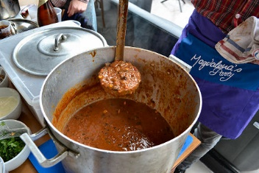
Bloody Mary $15.00 = $__________
This Photo by Unknown Author is licensed under CC BY-NC-ND
Beans $15.00 = $__________
People’s Choice Beans $15.00 = $__________
Hometown Chili(77995) $25.00 = $__________
CASI Chili $25.00 = $__________
People’s Choice Chili $15.00 = $__________
Margarita $15.00 = $__________
Total Due for Events = $ __________
Showmanship No Fee YES or NO
RV Spot (Out of Town CASI Cookers Only) YES or NO (available Friday 2PM)
Hometown Chili, head cook must reside in zip code 77995.
CASI Rules can be found at www.casichili.net under Cookoff/Resources!!!

Schedule:
Friday 6:00PM – Cook’s Dinner, provided by Chamber Directors in tent downtown
Saturday 7:00AM – Set Up – First Come, First Serve; spots roughly 10’ x 10’. Hometown Cookers
on West Grand and CASI Cookers on Lott Street. Move vehicles by 8:35AM.
8:00AM – Registration day of event til 9:00am
Turn-in times:
10:00 AM – Bloody Mary 2:00 PM – CASI Chili
12:00 PM – Beans 2:30 PM – People’s Choice Chili
12:30 PM – People’s Choice Beans 2:30 PM – Showmanship Judging
1:00 PM – Hometown Chili 4:00 PM – Margarita
5:00 PM – Awards in Entertainment Tent
Make checks payable to:
Yoakum Area Chamber of Commerce
P.O. Box 591
Yoakum, Texas 77995
Entries may be dropped off, mailed or emailed to info@yoakumareachamber.com. Payment may be mailed in to address above. We will accept cash, check, money order or credit card. There will be a 3.5% convenience fee added for credit card payments. Payment must be made in full to be entered into Cook off. If you have questions, please call the Chamber at (361) 293-2309.
I agree to keep, save and hold harmless the Land of Leather Days Committee, Yoakum Area Chamber of Commerce and CASI from all liabilities.

________________________________________________
Head Cook Signature

